Julius Ranoa

CSC 121 001 Computer Science I

Homework – Chapter 13 Advanced File I/O

**Programming Challenge @ Page 911.**

Qn. 1 – File Previewer.

There are four screenshots attached below.

1. Input: A file with more than 10 lines of text.  
   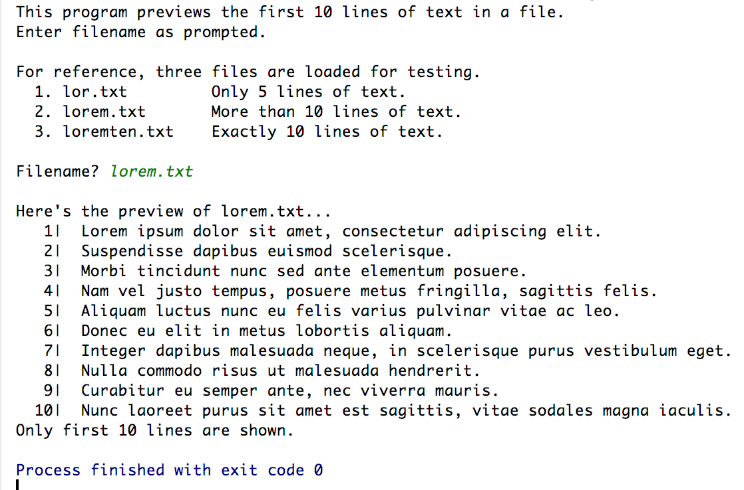
2. Input: A file with exactly 10 lines of text.  
   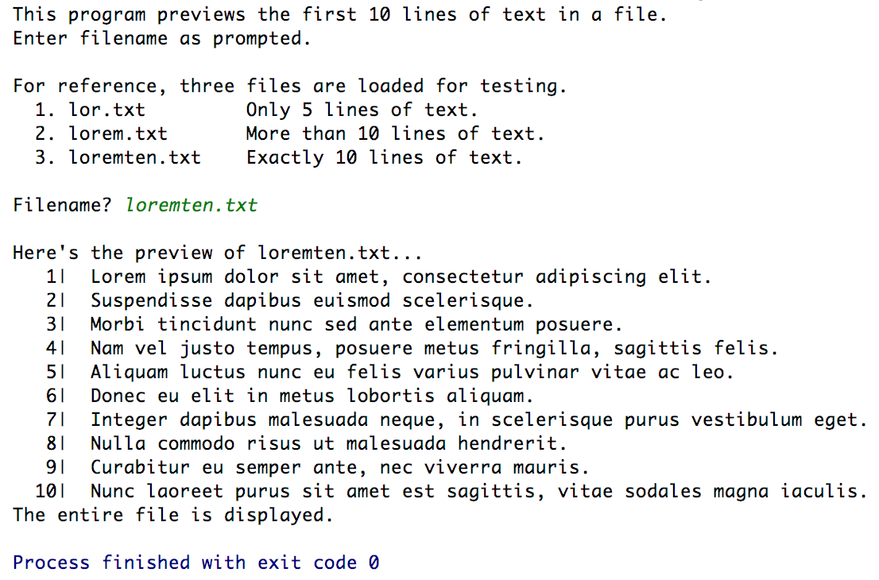
3. Input: A file with less than 10 lines of text.  
   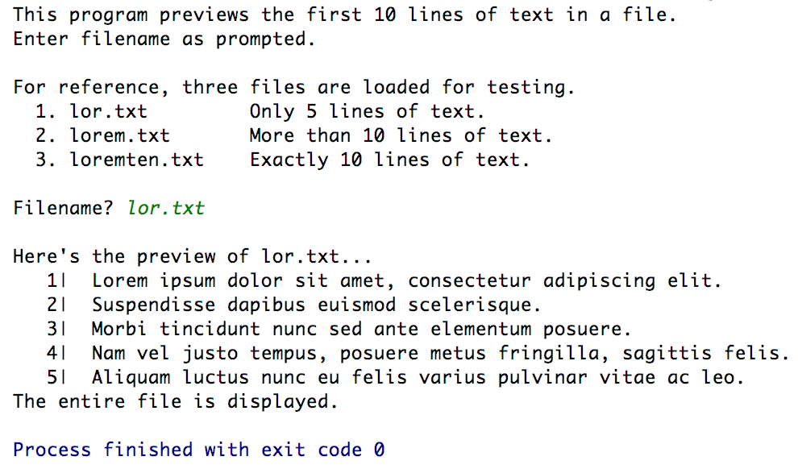
4. Input: Invalid filename / File not on project folder.  
   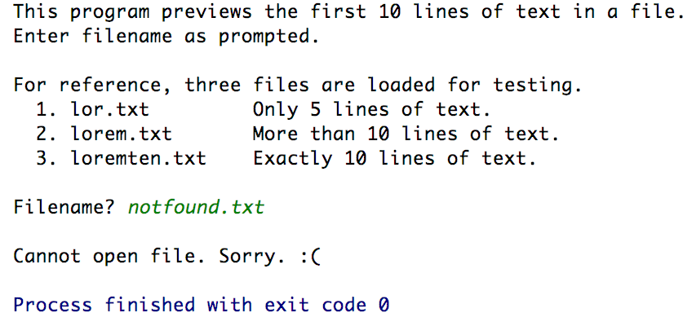

There are three source files and three test text files in the project folder.

1. main.cpp
2. FilePreviewer.h
3. FilePreviewer.cpp
4. lor.txt
5. lorem.txt
6. loremten.txt

The original project folder is also stored at Github.

Link below:

<https://github.com/TheLoneWoof1102/FA17_CSC121001/tree/master/Source%20Code/>

1. **main.cpp****» *end of main.cpp***
2. **FilePreviewer.h****  
   » *end of FilePreviewer.h***
3. **FilePreviewer.cpp****  
   » *end of FilePreviewer.cpp***
4. **lor.txt****  
   » *end of lor.txt***
5. **lorem.txt****  
   » *end of lorem.txt***
6. **loremten.txt****  
   » *end of loremten.txt***